King Fahd University of Petroleum & Minerals
COE 292: Introduction to Artificial Intelligence
Dataset Report

Project Name: | Cyber Threat Detection
Student Name: | YAZED BADER ALMUTAIRI
KFUPM ID | 202164390
Date: | 2/15/2025

Summary of Classification problem
The classification problem focuses on identifying cyber threats in network traffic using machine learning. The CyberFedDefender dataset includes both normal and malicious traffic, with attacks such as DDoS, Brute Force, and Ransomware. The features represent network metadata, such as packet size, duration, byte transfer, flow rates, and TCP flags, which are crucial for intrusion detection systems (IDS). These features help distinguish between normal and anomalous behaviour, but the challenge lies in the similarity between attack patterns and normal traffic. Attackers constantly evolve their methods, making it difficult to create static rules for classification. Additionally, the dataset is designed for federated learning, meaning data is distributed across multiple locations, introducing variations that further complicate classification. Accurately detecting cyber threats is essential in cybersecurity to prevent data breaches, service disruptions, and financial losses. This classification is crucial for real-time threat mitigation, improving automated security systems, and enhancing privacy-preserving threat detection across cloud and edge computing environments.

Source:
https://www.kaggle.com/datasets/hussainsheikh03/cyber-threat-detection

Statistics

No. | Question | Student Response
1. | How many labeled examples are in your data set? | 1430
2. | How many distinct features are in your data set? | 21 ( excluding Timestamp and Label )
3. | How many distinct labels (classes) are in your data set? | 4 ( DDoS, Ransomware, Normal, Brute Force )
4. | For each label, what is the percentage of data? | DDoD : 26.36%  Ransomware : 25.24%  Brute Force : 24.62%  Normal : 23.78%
5. | Is the dataset balanced based on the above? | [ X ] Yes [ ] No
6. | Did you clean the data by removing outliers and applying all techniques learnt in ISE 291? | [ X ] Yes [ ] No

Feature (variable) explanation

No. | Feature used in file | Short Feature explanation/description
1. | Protocol | The network protocol used (TCP, UDP, ICMP).
2. | Packet_Length | The length of the packet in bytes.
3. | Duration | The duration of the connection in seconds.
4. | Source_Port | The port number used by the source.
5. | Destination_Port | The port number used by the destination.
6. | Bytes_Sent | Total bytes sent from the source to the destination.
7. | Bytes_Received | Total bytes received by the destination from the source.
8. | Flags | TCP flags indicating the connection's state (e.g., SYN, ACK).
9. | Flow_Packets | Number of packets per second in the traffic flow.
10. | Flow_Bytes | Number of bytes per second in the traffic flow.

Label explanation

No. | Features used in file | Short Feature explanation/description
1. | Label | Binary classification label where 1 indicates malicious traffic and 0 represents normal traffic.  Usage
2. | Attack_Type | Type of cyberattack or normal traffic (e.g., DDoS, Brute Force, Ransomware, Normal)
3. | Inbound | Indicates whether the traffic is inbound (1) or outbound (0).

Data visualization

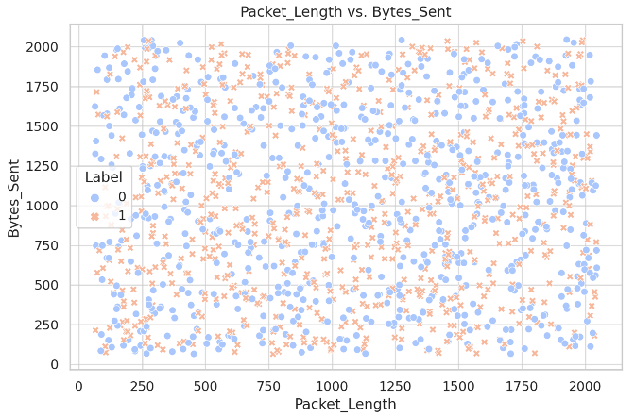  Figure 1 | 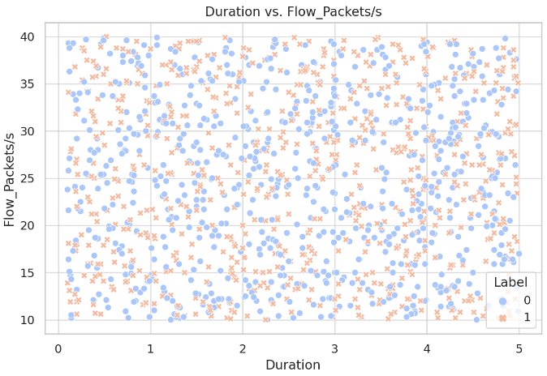  Figure 2
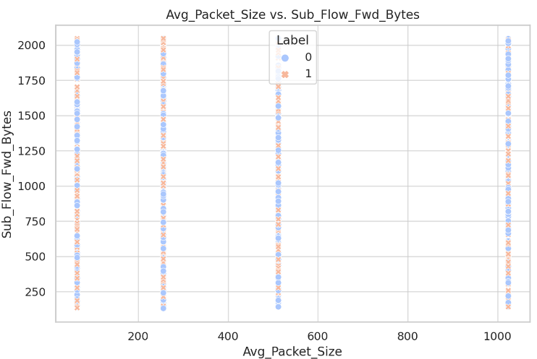  Figure 3 | 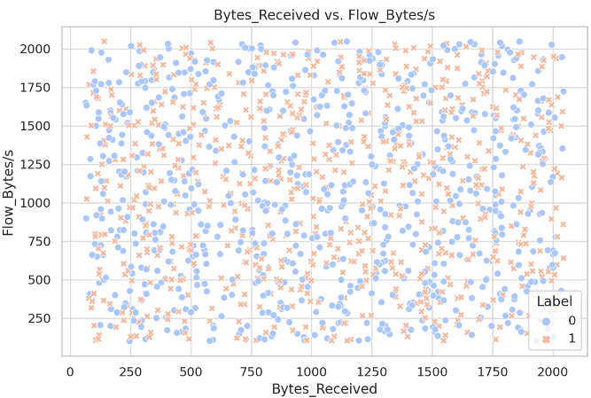  Figure 4
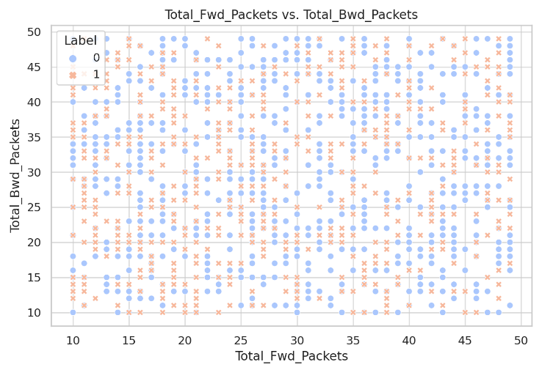  Figure 5 | 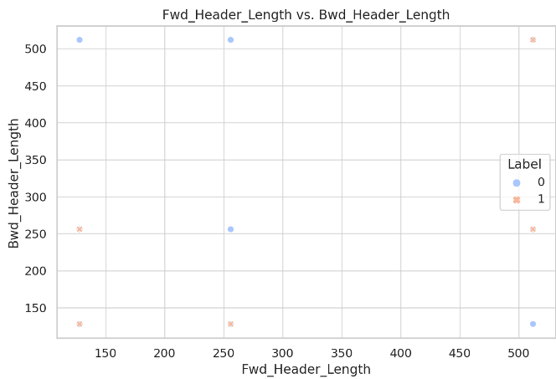  Figure 6
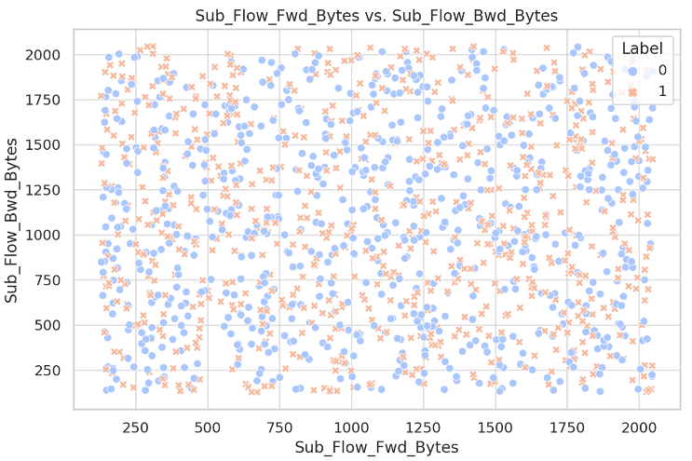  Figure 7 | 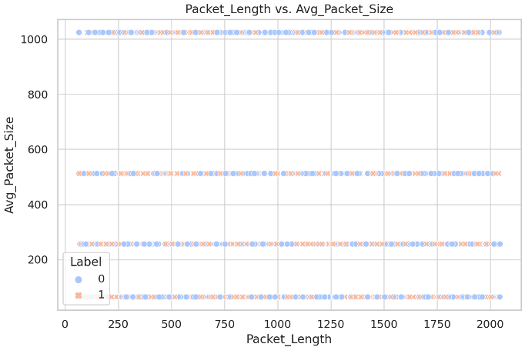  Figure 8
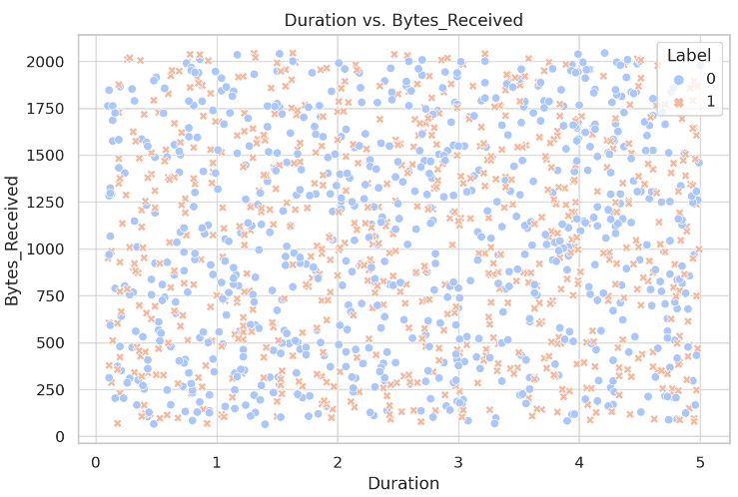  Figure 9 | 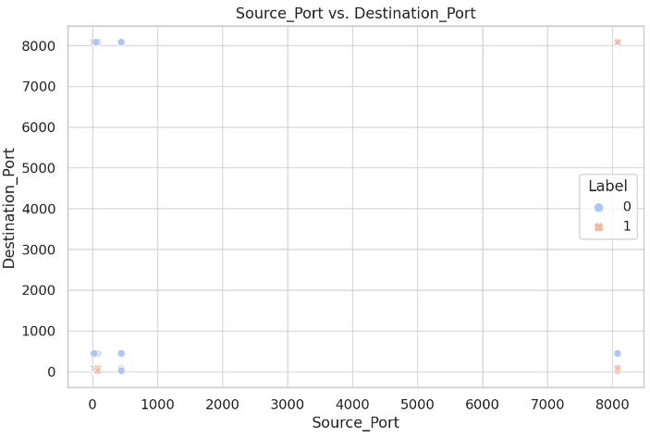  Figure 10

Conclusion
In the field of Information and Computer Science, classification of cyber threats plays a critical role in enhancing cybersecurity measures. Implementing an effective classifier helps in accurately detecting and mitigating cyber threats in real time, which is vital for maintaining the integrity and security of network systems. By identifying potential threats early, such classifiers empower professionals to prevent significant data breaches and financial losses, ultimately safeguarding both individual privacy and organizational data across diverse computing environments.

